PLANETARY HEALTH TRANSECT
Route Briefing for Participants

Kathmandu → Chitwan → Pokhara → Lower Mustang (Marpha) → Upper Mustang
This briefing is designed to help participants understand what they will observe while traveling each stretch of the transect. Read the relevant section before departure or during travel. Each section covers what to expect in terms of geography, geology, ecology, climate, settlements, culture, and land use.
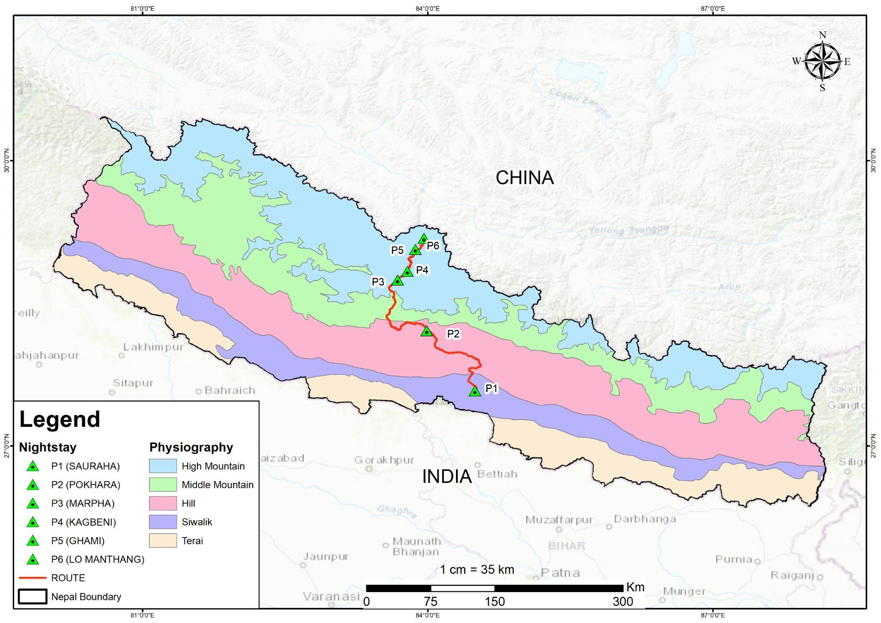

Stretch 2 | Chitwan to Pokhara

Landscape & Geography

Starting Point: Chitwan
Located in the Inner Terai, this region is characterised by flat, broad longitudinal valleys like the Rapti Valley. Historically covered in dense virgin forests, much of the landscape is now dominated by fertile agricultural land and settlements.

The Transition
As you move north toward Pokhara, you leave the Gangetic plains and cross the Siwalik Hills (Churia Range), which rise between 200 and 700 metres. The terrain becomes increasingly rugged as you enter the Mahabharat Range, where steep slopes and terraced fields become the defining features.

Destination: Pokhara Valley
Pokhara is situated in the Midlands, a physiographic zone between 600 and 3,500 metres. The landscape here is a broad valley floor surrounded by hills, featuring a unique geological setting known for its natural beauty and proximity to the high Annapurna peaks.

Climate
You transition from the Subtropical zone of the Terai to the Warm Temperate zone typical of the Midlands.
- Chitwan: Significantly hotter and more humid, especially during the monsoon (June–September) when temperatures can reach 33°C. Winters remain mild, with temperatures between 7°C and 23°C.
- Pokhara: Due to its higher elevation, generally experiences more moderate temperatures than the Terai plains.
- Precipitation — The Wettest Transition: One of the most significant climatic changes is the increase in rainfall. While both regions are heavily influenced by the summer monsoon, the Pokhara Valley is one of the wettest places in Nepal, receiving an average annual precipitation of approximately 3,800 mm. Travelers are more likely to experience heavy, persistent rain in Pokhara compared to the southern plains.
What to Observe: As you leave Chitwan, notice how quickly the flat land gives way to hills. Watch the fields — they shift from flat paddies to narrow strips cut into steep slopes. As you get closer to Pokhara, does the air feel different? Does the sky look different? You are moving into one of the wettest parts of Nepal.

At-a-Glance Summary
Feature | Chitwan (Inner Terai) | Pokhara (Midlands)
Topography | Flat plains and broad low valleys | Hilly terrain with a broad valley floor
Climate Zone | Subtropical | Subtropical to Warm Temperate
Typical Weather | Hot, humid, and tropical | Moderate temperatures, extremely high rainfall
Primary Vegetation | Sal forests and agricultural fields | Temperate mixed forests and urbanised valley land

